The History & Evolution of DISC

Four-Factor Models through History

 |  | HOT
 | AIR | FIRE
TEW |  |  | YRD
 | WATER | EARTH

COLD

Even the ancient Greek approach used a primitive 'biaxial model' to relate the elements to one another.

NEUROTIC

TREVORTNI | M | C | TREVARTXE
 | P | S

STABLE

A more modern model, that of Hans Eysenck. Though more rigorously defined, this model still retains the old names for the basic types: Melancholic, Choleric, Sanguine and Phlegmatic (marked M, C, S and P ).

ASSERTIVENESS
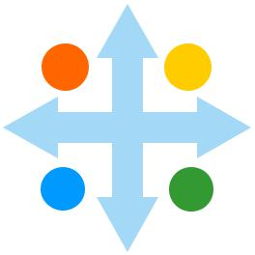

LORTONC | D | I | SSENNEPO
 | C | S

RECEPTIVENESS

Though DISC is based on a model of its own, it maintains the continuity of breaking down personality into four quadrants based on two axes.

Into the Modern Era

Though the less scientific ideas of Hippocrates and Galen were dropped as science advanced, studies based on the four temperaments continued until remarkably recently. As the concepts behind personality began to be investigated more rigorously, statistical analysis began to break down personality factors in a more scientific way.

One of the foremost proponents of this approach was Hans Eysenck, whose analysis resulted in a biaxial model mapping factors against a pair of traits. Eysenck himself remarked on how similar this result was to the old idea of the temperaments, though the factors themselves were more technically defined.

...four behavioural factors: dominance, influence steadiness and compliance

There are numerous comparable approaches (notably that of Carl Jung, whose personality work is partly based on a relationship of this kind).

William Marston and DISC

One of these models was developed by American psychologist and writer William Moulton Marston, in his 1928 book Emotions of Normal People.

This was the ultimate prototype of the DISC profiling technique: a pair of axes producing a set of four interconnected factors, initially called Dominance, Inducement, Submission and Compliance.

During the 1940's Marston's profiling technique came to prominence, when it was adopted by the U.S. military to help in recruitment during World War Two. Over the following decades its simplicity and flexibility meant that it became more widely used worldwide.

In the early days, DISC profiles were created from paper questionnaires, marked and assessed by hand. With the advent of personal computers and the Internet, DISC adapted itself easily to a more automated approach, so that tests can now be managed in a completely automated way.

The Reliability & Validity of DISC

Measuring the Effectiveness of DISC

To be confident that DISC actually works, we need to consider its reliability and validity. These two concepts help to quantify the performance of all profiling tools.

an effective profile, we're looking for a high reliability score. Note that people's attitudes and approach change over time, so we wouldn't expect to see a 100% reliability level from one profile to the next. (understanding changes like this can be valuable in assessing a person's performance.)

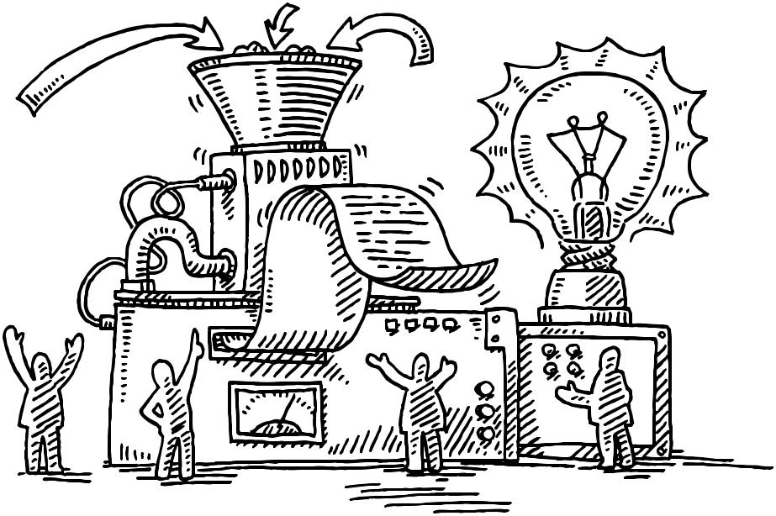

factors in one test demonstrate a consistent statistical relationship with those in the other.

The most important question about any personality test is how well it measures what it claims to measure. We need to be confident that profiles accurately represent the personalities they describe.

Reliability

The first measure is consistency: if we test the same person several times, we'd expect to get similar results. Reliability measures how much profile results change from test to test ( there are different types of reliability, and the form we're discussing here is specifically test-retest reliability).

We'd not expect results to vary wildly from profile to profile over time, so for

Validity

A more difficult challenge is assessing the validity of a set of profile results: do the factors in a profile measure the personality traits they describe. The usual approach is to measure profiles against another well- stablished personality inventory. The preferred comparison is Cattell's Sixteen Personality Factor questionnaire (or 16-PF for short).

Different profiling techniques measure different factors, so we wouldn't expect to find exact matches in the comparison. We can, however, look at correlations between factors in the two systems, to establish whether

DISC Profiles: The Basics

Introducing the DISC Profile

After collating and calculating the answers from a DISC questionnaire, the final outcome is a set of three graphs. Each of these graphs (or profiles) describes a particular side to the candidate's approach. In combination, the set of three is known as a DISC profile series.

The graphs all follow the same format, showing the levels of four basic traits: Dominance, Influence, Steadiness, Compliance. Their initials (D, I, S, C) create the name DISC. The four points on the graph are connected by lines to establish a recognisable shape for a profile. With experience, the shapes associated with common styles become easily distinguishable.

Graphing a DISC Profile

The DISC graph shows how the four factors are plotted. Each point shows the relative level of one of four factors, always from left to right

- D for Dominance

- I for Influence

- S for Steadiness

- C for Compliance

Each factor might appear at any point on the graph, leading to a series of recognisable profile shapes of personality styles. Understanding these factors, and how they combine to describe a personality, lies at the heart of DISC interpretation.

The three graphs of the profile series might closely resemble one another, or diverge significantly, depending on the individual. Different DISC systems use different titles forthe three, and their order can vary, but the meaning and significance remains constant.
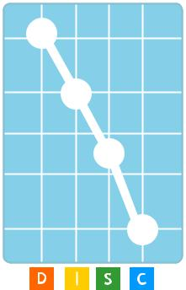

The Internal Profile

The graph describes a person's inner style, the behaviour when they feel completely at ease. Conversely, this style can be seen when some people are placed under severe pressure, because such pressure limits their capacity to adapt their style. The Internal Profile tends to remain more constant over time than the other two graphs. Other names for the Internal Profile include the Pressure Profile and the Underlying Profile.

The External Profile

Very few people maintain the same approach, instead, they adapt to situations and others' requirements. The purpose of the External Profile is to describe the style of behaviour that an individual feels is appropriate to their current circumstances. The External Profile can change considerably over time, as a person's situation and environment changes - such modifications often accompany major life events, such as starting a new job or moving house. The External Profile is also known as the Work Profile or the Mask Profile.

The Summary Profile

The Internal and External Profiles provide valuable information about a person's attitudes and perceptions. In reality a person's behaviour is rarely based completely on one or the other of these styles. The Summary Profile combines information from the other two to present a view of a person's actual behaviour. Other names for this profile are the Basic, Composite or Snapshot Profile.

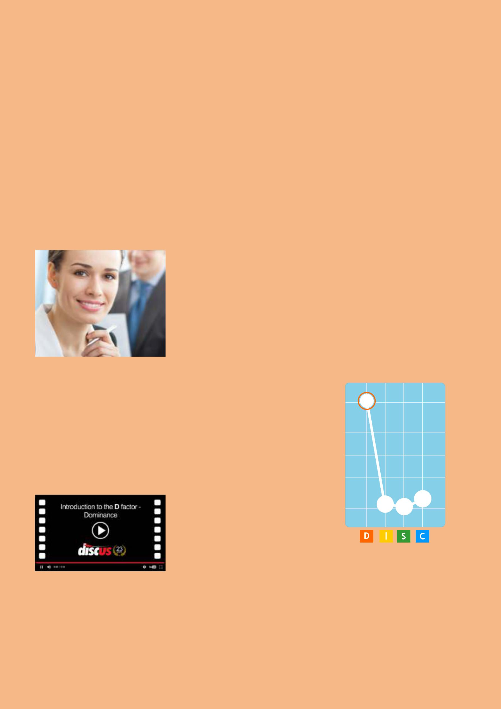
The D Factor: Dominance

The DISC Factor of Drive and Self-Motivation

The 'D' of DISC stands for Dominance, the factor of determination, ambition and motivation to succeed.

When a set of DISC results shows a high Dominance factor, they're describing someone with an independent attitude and a motivation to succeed on their own terms. High-D's, (as we call this type of person), have the strength of will to work well under pressure, and are always ready to take on responsibility.

Highly Dominant people have a clear idea of their ambitions and goals, as well as the directness and forcefulness to achieve those goals. It also means that people like this will tend to have a competitive attitude, and they will generally follow their own ideas rather than work co-operatively with others.

Low Dominance in a DISC profile invariably shows a lack of directness. They'll tend not to confront a difficult situation head-on, though they may find other effective ways of dealing with things (exactly how they'll do this depends on the other factors in their personality). They also tend to be much readier to work productively as part of a group than their more independent High-D colleagues.

...an independant attitude and a motivation to succeed on their own terms

Dominance at a Glance

Self-reliance: High-D's rely on their own independent resources, rarely looking for help or support from those around them.

Competitiveness: People like this are motivated by success, especially tangible success in competition with others.

Ambition:Dominance relates to a clear set of goals or ultimate aims, and the determination to work towards those goals.

Decisiveness: High-D's generally have little patience, and will prefer to make a rapid decision, even it that involves a degree of risk.

Leadership: Their preference for independence and their forthright attitude means that people of this kind will tend to work towards leadership roles.

D

The D Factor: Dominance

Common Roles

A High-D's sense of independence and personal responsibility means that they will tend to gravitate towards roles where they have the greatest possible scope for action. They'll also tend to avoid situations where they're reliant on other people for support, or subject to too much control.

Dominance is often a useful trait in a manager or leader, especially in situations where there's a need for decisive action and clear direction. Note that this certainly doesn't mean that High-D's always make effective leaders - that depends to a huge degree on the situation - but the core features of this kind of personality tend to match well with the challenges of leadership.

Dominance is often a

useful trait in a manager, especially where there's a need for decisive action and clear direction.

Another type of role classically associated with high Dominance is that of sales, especially direct sales. The factor gives a person the force of personality to make a strong pitch, and the resilience to close a sale in situations that other types would find highly disconcerting. This is especially true whether Dominance combines with high Influence, representing a person with a persuasive element as well as the determination of Dominance alone.

Dominance Scenarios

Below are a number of examples of ways that a High-D person will act and react in some common real-world situations.

Making a Decision

High-D's are commonly described as 'decisive', but this is meant in the sense that they'll prefer to make a rapid decision, and potentially take a risk, rather than take time to evaluate all the options or possible outcomes. At least, this is the typical approach of a 'pure' High-D, with no other strong factors. Additional factors can complicate the picture: a High-D who also shows high Compliance, for example, will tend to be more receptive to the details affecting a decision

Planning Ahead

High Dominance isn't associated with the organisation or the natural caution that go into detailed planning. As we saw in their approach to decision-making, a person like this will prefer to follow their instincts, and they'll often be ready to disregard a planned course of action if they see an alternative opportunity.

Handling a Dispute

High-Ds tend to have uncompromising personalities, and aren't afraid to confront other people directly if they think a situation calls for it. So, it's not uncommon to find them involved in disputes with others, but resolving disputes like this can be difficult. A highly Dominant person will need to feel that they achieve some real advantage from any possible resolution.

Sub-Traits with High Dominance

Efficiency | D
D/I : Dominance Higher than Influence
Efficiency appears in a DISC profile when Dominance is significantly
higher than Influence. An efficient individual is direct and assertive,
but has little or no interest in personal matters. They take an
objective, analytical view and drive towards their goals ruthlessly
and relentlessly. They need to see results, and are quite willing to | I
compromise quality or detail to get them.
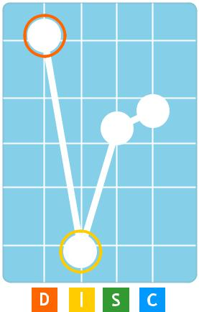

Self-Motivation

D/S : Dominance Higher than Steadiness
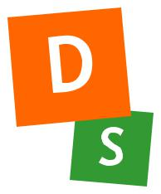

Self-motivation appears in a DISC profile when Dominance is significantly higher than Steadiness. Action is a key ingredient of this sub-trait. This type of person feels a need to be active all the time, and is impatient with those who are unwilling or unable to keep up with their urgent pace. They react quickly to new developments, but never lose sight of their own goals and ambitions.

D
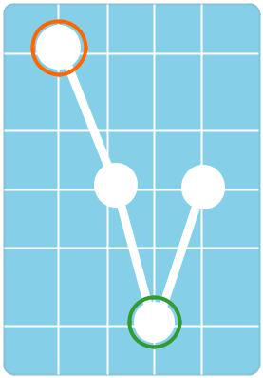

S

Independence

D/C : Dominance Higher than Compliance

Independence appears in a DISC profile when Dominance is significantly higher than Compliance. This type of person feels frustrated by rules and regulations - they prefer to follow their own ideas, and often work alone or in positions of isolated authority. This sub-trait is common, for example, in entrepreneurial styles.

D
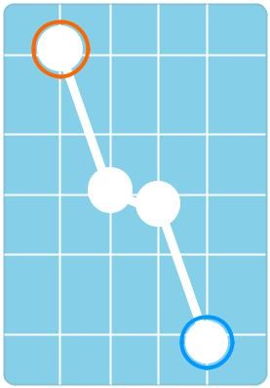

C

The I Factor: Influence

The DISC Factor of Openness and Positive Communication

The 'I' of DISC stands for Influence, a factor connected to communication, openness and social confidence.

When a set of DISC results shows a high Influence factor, they're describing someone with a positive attitude to other people and the confidence to demonstrate that attitude. High-I's, (as we call this type of person), are at their most comfortable in a social situation, and interact with others in an open and expressive way.

This focus on other people means that High-I's thrive on the attention and approval of other people, and they're more motivated by praise and appreciation than most other types. Despite their outgoing attitude, they're often unwilling to risk causing offence, and they'll often avoid possible confrontations. In other words, while a High-I is socially confident, they tend not to be particularly assertive or forceful.

Low Influence in a DISC profile, implies a personality far less concerned with expressing themselves or interacting with others. Low-I's tend to turn their focus on more practical topics, concerning themselves more with achieving results than with building relationships.

Influence at a Glance

Self-confidence: High-I's are

conspicuously confident in the company of others, and generally find it easy to form friendly relationships.

...a positive attitude towards people and the confidence to demonstrate it.

Sociability: Strong Influence relates to a person who goes out of their way to build warm and positive relations with other people.

Expressiveness: Their outgoing natures means that people like this tend to say what's on their mind in an open way.

Informality: People like this prefer to communication on a personal and relaxed level rather than be bound by formality.

Enthusiasm: When engaged by an idea or topic, the naturally positive attitude of a High-I is often highly motivating for those around them.

I

The I Factor: Influence

Common Roles

The social impulses of a High-I individual mean that they'll be attracted to roles where these needs are fulfilled. High Influence individuals will be at their most motivated surrounded by other people, and with the scope to communicate freely. Conversely, they will tend to avoid more constrained or socially limiting situations.

A natural outlet for a High-I's outgoing style is in the area of sales, marketing or PR, especially in roles where they are able to use their communicative abilities to their fullest. One potential drawback here is that people with just high Influence in their profiles tend to lack the directness to close a sale, and a measure of Dominance can also be important in more challenging situations like direct sales.

Those with high Influence are often found in roles that involve teaching or training, and they can be highly effective in not only communicating ideas, but also inspiring others with their dynamic attitude.

Roles of this kind will usually also need a level of expertise and knowledge, but high levels of Influence within the personality can

Influence Scenarios

Below are a number of examples of ways that a High-I person will act and react in some common real-world situations.

Making a Decision

High-I's have the confidence to act in a decisive manner, but their focus on other people means that their decisions are often based on the popularity of the various outcomes, rather than purely practical considerations.

Working Within a Team

In some senses highly Influential people are ideal team players. They are actively interested in building positive working relationships, and they have the natural confidence to help direct the team as a whole. They do tend to take a rather informal approach at times, and this can be counterproductive where the team is working in more pressured conditions.

be an important component.

Presenting Ideas

Of all the factors, Influence is most connected with people who are comfortable with presenting ideas in front of an audience. Indeed, they often find situations like this to be motivating and rewarding, a fact that lends them an assured and enthusiastic presentation style.

High Influence individuals

will be at their most motivated surrounded by other people

Sub-Traits with High Influence

Friendliness

I/D : Influence Higher than Dominance

Friendly people love to talk - communication is the strongest element of this style. They are outgoing and extrovert, but they find it far from easy to concentrate on mundane tasks, and are easily distracted from such work by the opportunity for social interaction.

I
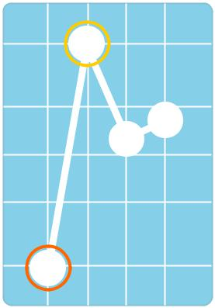

D

Enthusiasm

I/S : Influence Higher than Steadiness

This is an outgoing and extrovert sub-trait that has much in common with Friendliness, but with the added dimension of energy and pace. This animated style shows their interest in a topic very strongly, and their effusive nature can act as a motivating factor for others.

I
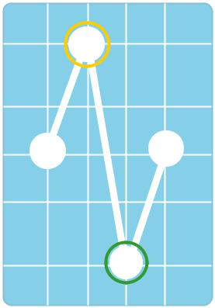

S

Self-Confidence

I/C : Influence Higher than Compliance

Self-confident profiles represent people who rarely experience self-doubt, and feel at ease in almost any social situation. They mix easily with strangers, and are unafraid to initiate social contact. They can at times become over-confident, leading them to act impulsively.

I
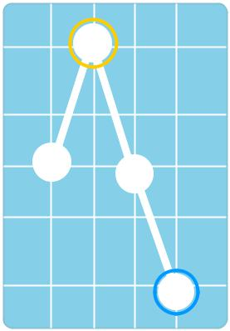

C

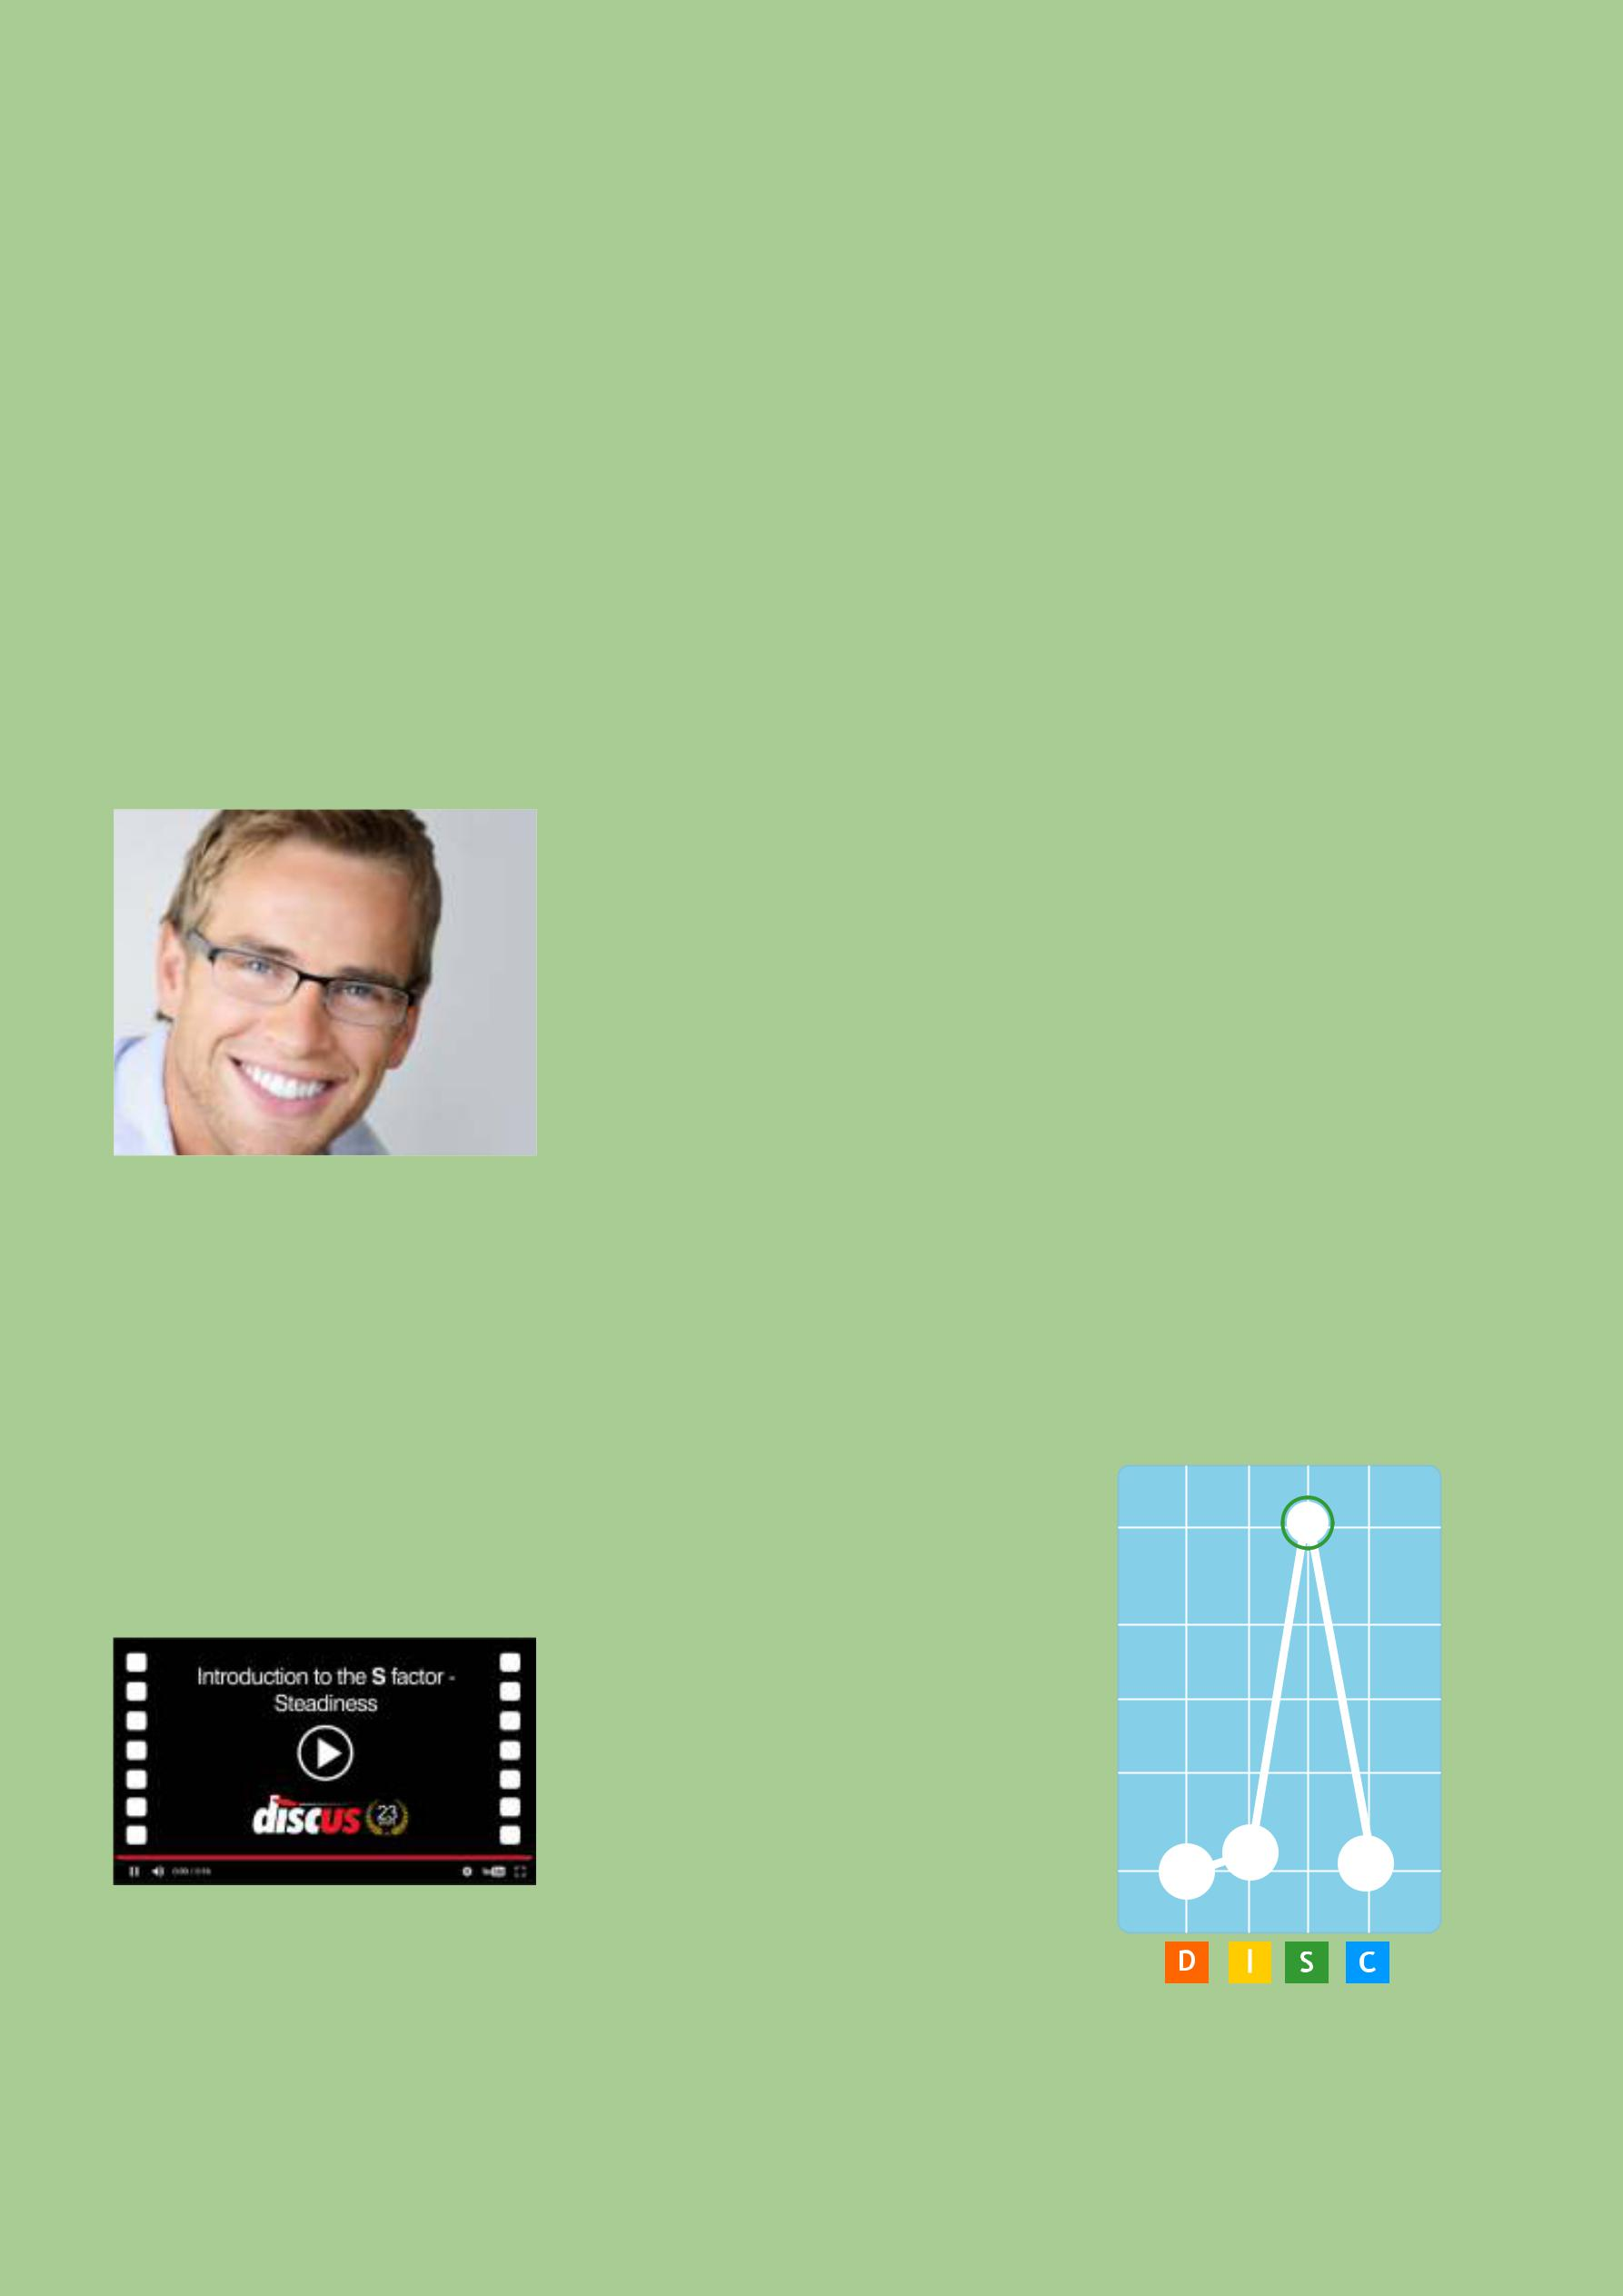
The S Factor: Steadiness

The DISC Factor of Patience and Reliability

The 'S' of DISC stands for Steadiness, a factor relating to a person's natural pace, and their reactions to change.

The third of the four DISC factors relates to a comparatively reticent and careful type of person. Compared to Dominance or Influence, a person whose major factor is Steadiness will tend to be far less open or direct. They'll more usually respond to events, rather than take pro-active steps.

As the name implies, Steady people are consistent and reliable in their approach. Indeed, they prefer to operate in situations that follow established patterns, and to avoid unplanned developments. Because of this, people with high Steadiness

consideration associated with a High-S. Far from resisting change, people with low Steadiness enjoy variety and innovation, giving them a much more flexible outlook than those with high Steadiness. As such, they're ready to take on new challenges and explore new experiences.

Steadiness at a Glance

Patience: High-S's will tend to wait for events to unfold and respond as needed, rather than taking direct action of their own.

Determination: High-S personalities focus intently on a task, and can be remarkably resolute in concentrating on a project.

Openness: Steadiness also has a social side, and people with this factor are open to building positive relations with other people.

Consideration: The 'S' factor relates to people who tend to think about the consequences of their actions, especially on those around them.

tend to be quite resistant to change, and will take time to adapt to new situations.

Low Steadiness in a DISC profile reflects a person with a quite different attitude. Low-S individuals are eager to act and impatient for results, and rarely show the patience or

High Steadiness Individuals | S
focus intently on a task and
can be remarkably resolute in
concentrating on a project

Persistence: Once embarked on a

course of action, a High-S person

will focus on their task and work

persistently towards its conclusion.

The S Factor: Steadiness

Common Roles

A High-S is best suited to roles where their natural advantages can come to the fore: situations where patient, reliable work is needed. A consistent working environment is ideal for this type of person, with minimal distractions or unplanned events.

The strengths of a High-S - patience, reliability, consistency - make them particularly suited to administrative work. They have the capacity to apply themselves and focus in a productive way. Work like this can often lack variety, but while many types wouldn’t find such a prospect motivating, it fits neatly with a High-S's preferences !

High-S’s openness makes them ideal in roles that provide help and support. This is a broad area covering a wide range of potential work. At a practical level, High-S's will often be suited to technical support or customer service work. On a more personal level, their understanding and patient approach means that they can be successful providing personal support or counselling.

High-Ss love consistent working conditions with minimal distractions

Steadiness Scenarios

Below are examples of ways that a High-S person will act and react in some common real-world situations.

Following a Plan

A Steady type of person will feel at their most comfortable and motivated when operating within a well-planned project. Working consistently with others towards a prearranged goal is their preferred working method. This will tend to be less true, however, in situations where deadlines are close, or the plan needs to adapt to changing circumstances.

Taking a Leadership Role

A highly Steady type of person can be an effective leader and, indeed, so can any style, under the right

circumstances. Steady leaders will tend to work best where leadership involves organising other people within a relatively predictable and stress-free environment, where there's little need for urgent action or dynamic decision-making.

Adapting to New Conditions

A defining characteristic of a High-S type of person is a natural distrust of novelty. They tend to avoid change simply because it involves adapting to the new and the different. Where change is inevitable, a High-S will eventually adapt to a new status quo, but it will take time for them to acclimatise to their new conditions.

Sub-Traits with High Steadiness

Patience

S/D : Steadiness Higher than Dominance
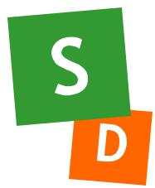

This style of person has little sense of urgency and a slow pace, which means that they are able to work in situations that others would find repetitive or dull. They are submissive in style, and ready to accept that there are some things that they cannot change.

S
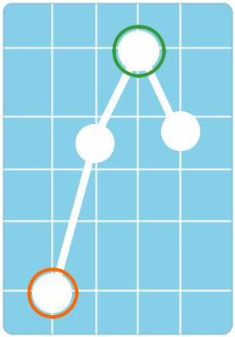

D

Thoughtfulness

S/I : Steadiness Higher than Influence

Thoughtful individuals plan their words and actions carefully and never act on impulse. Deadlines and other time constraints are difficult for this type of person to deal with. Their advantage, however, is the reliability and steadiness that they bring to their work.

Persistence

S/C : Steadiness Higher than Compliance

Persistent people deal badly with change. Once they are established in a status quo, they find it difficult to break out of this and adapt to a new situation. They will do what they can to maintain their current state of affairs, showing great loyalty and resilience in defence of their present environment and social circle.

S
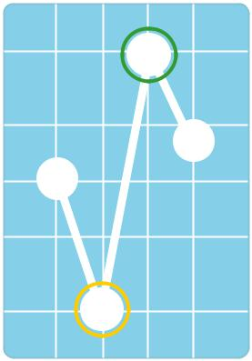

I
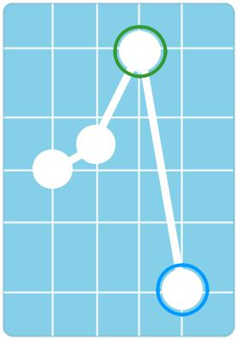

S

C

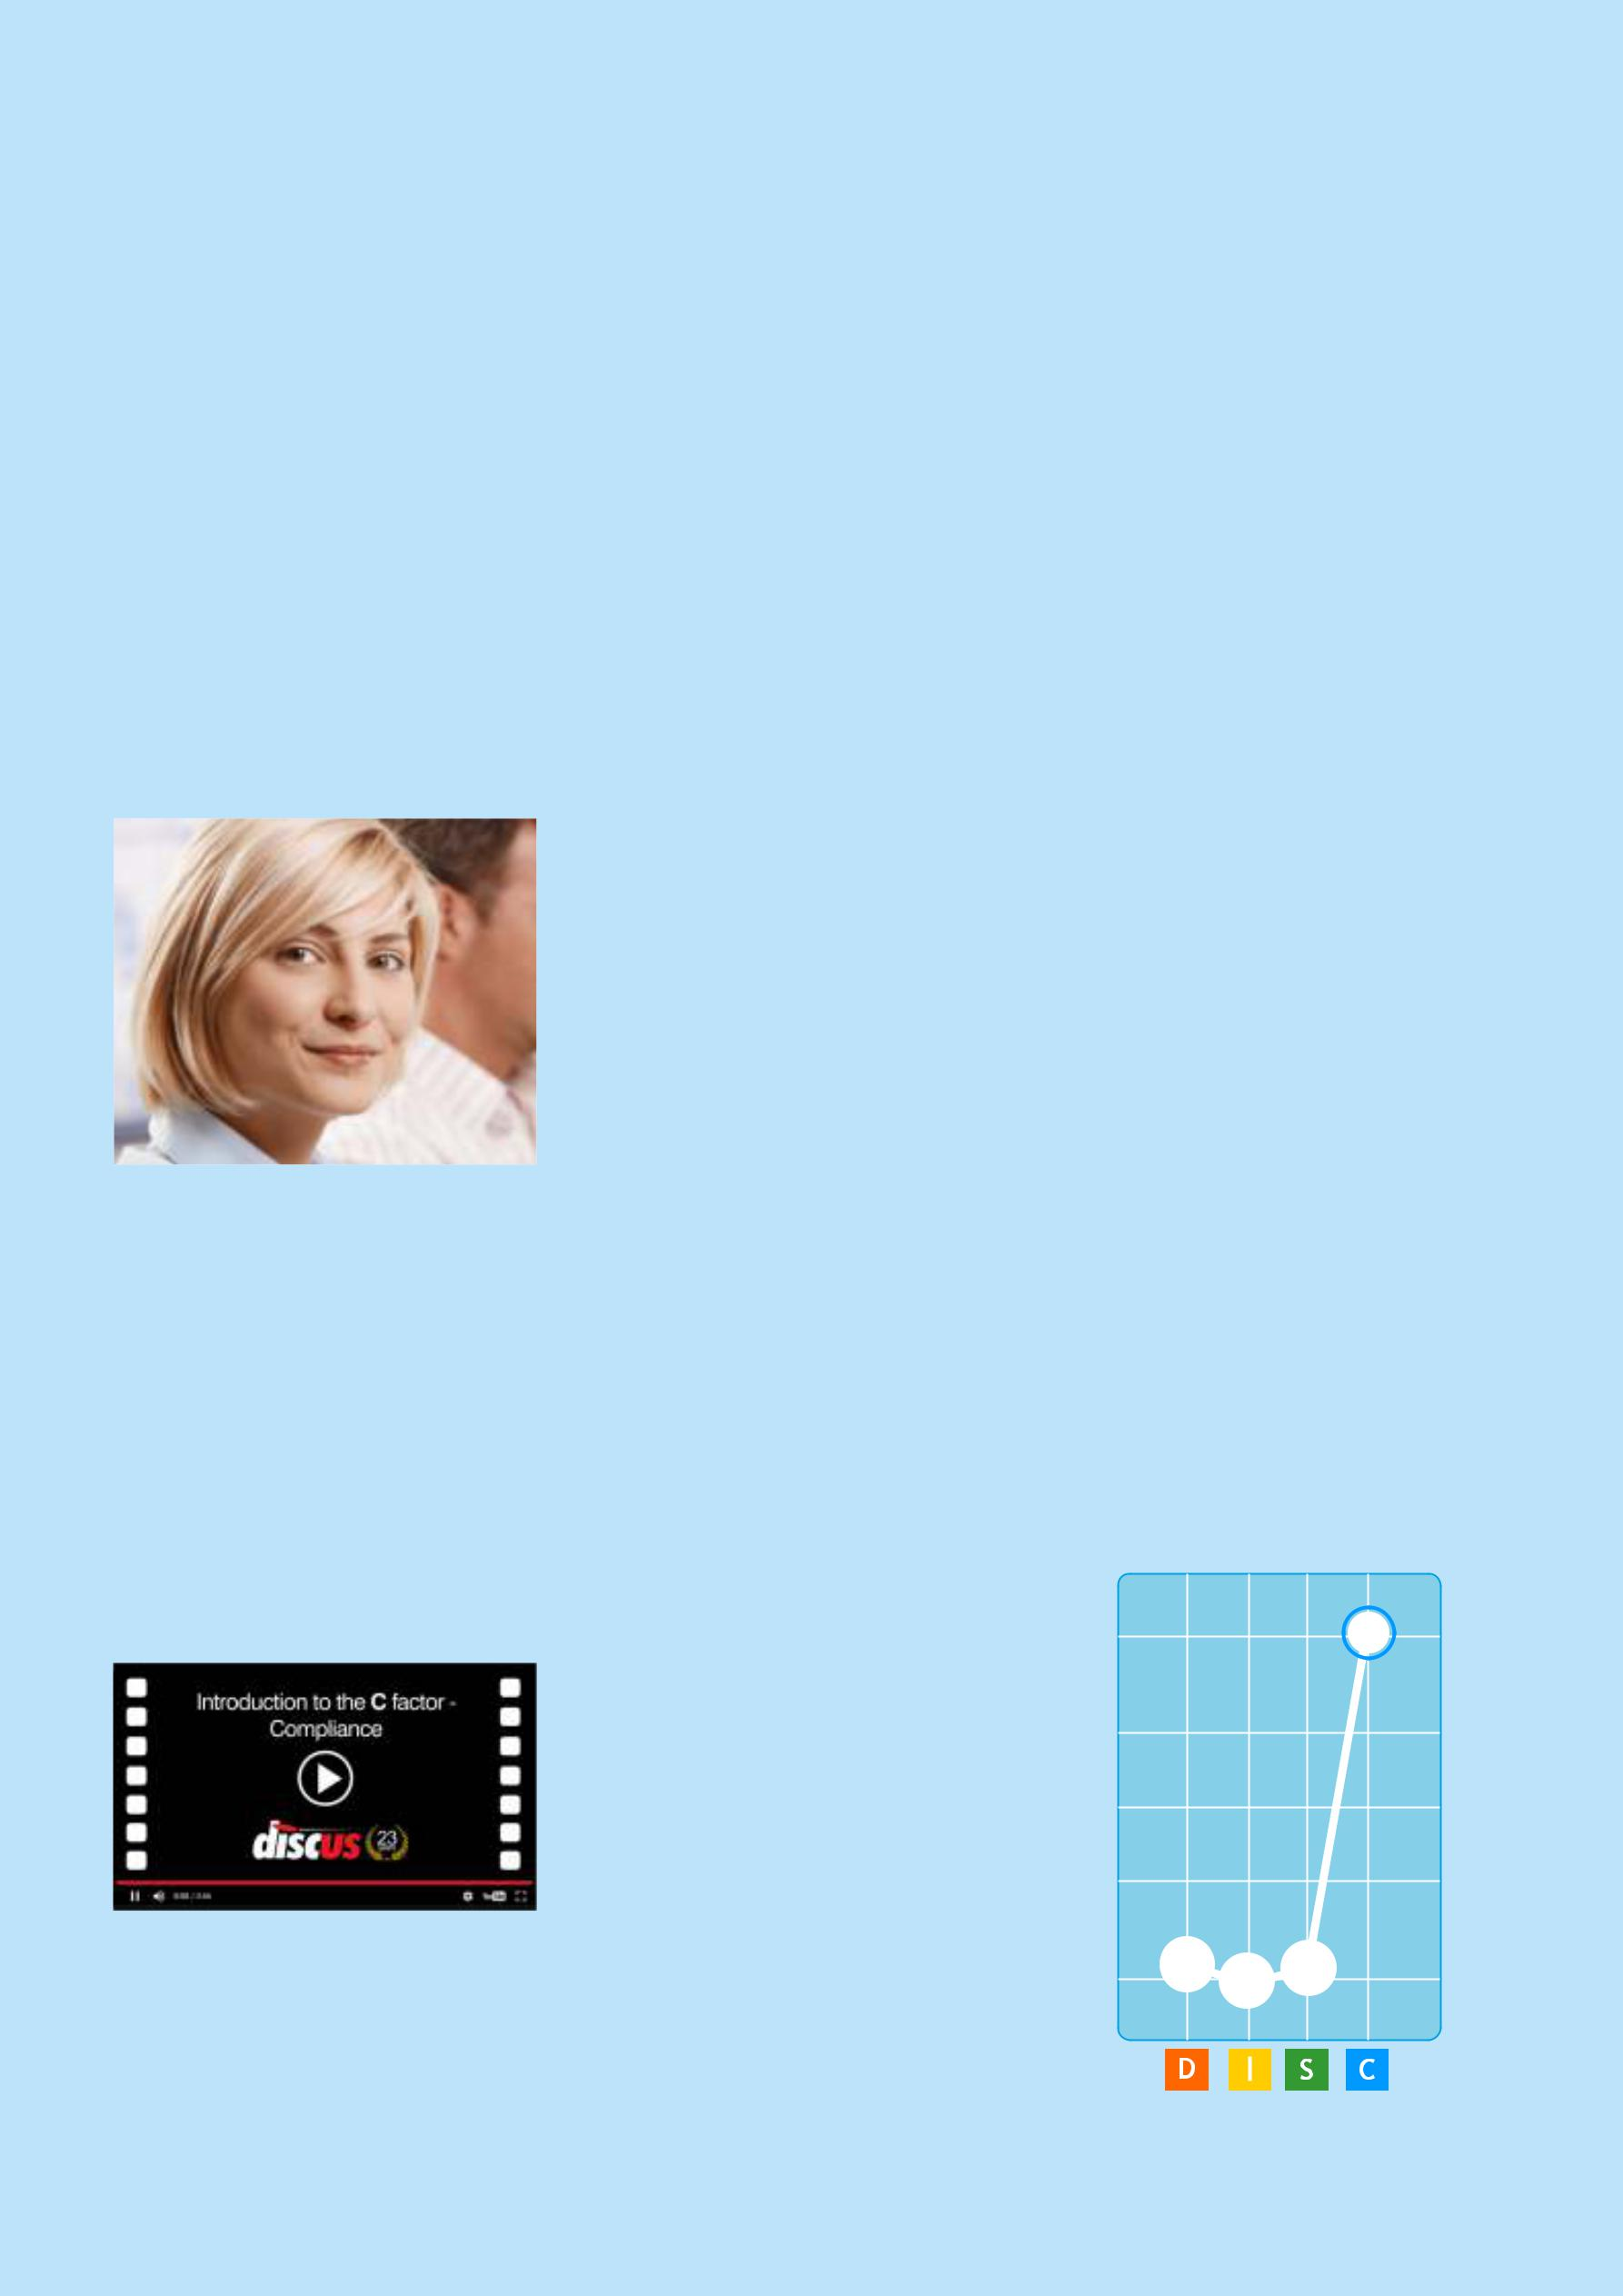
The C Factor: Compliance

The DISC Factor of Caution and Precision

A high Compliance factor indicates a concern for practicality and detail.

The key to this factor lies in attitudes to authority; High- C's are concerned with working within the rules, and are often described as 'rule-oriented'. They are also concerned with accuracy and structure, and understanding the ways things work.

People with high Compliance like to have a clear idea of their role, and what's expected of them, so they are far more motivated in situations that are clearly regulated and planned. In general, such people are not independent by nature, and will prefer not to be left to make decisions or take actions without the support of others.

Low Compliance people don't naturally focus on the need to plan ahead or anticipate problems; instead, they have the confidence to rely on their own instincts. While a High-C will rarely challenge authority or risk breaking a rule, a Low-C person has a much more independent and unconstrained attitude to their life and work.

Compliance at a Glance

Rule-orientation

High-C's like to work within an established and well-planned structure, rather than relying on their own resources.

Precision

Highly Compliance people are concerned with getting things right, and take time to ensure their work is accurate.

Caution

Highly Compliance people will tend to avoid risks when they can, preferring to take a cautious approach whenever they can.

Tact

High-Cs tend to be rather reserved in communication, using diplomacy and tact and focusing on matters of fact.

High Compliance Individuals | C
have a concern for
practicality and detail

Organisation

High-Cs will want to feel that they

understand the details of their

situation and how they fit into it.

Common Roles

High Compliance people are naturally motivated on roles where they can focus on details, facts and figures. High-C's - at least those without other factors in their profiles - tend to be at their best when they have time to organise and plan their work.

Their analytical approach, and desire to follow procedure, makes them well-suited to roles we might broadly categorise as 'technical'. That includes work that we normally think of as technical, such as engineering or programming, but the same idea can be extended to roles needing similar skills, such as accountancy or project planning.

A High-C's affinity for questions of accuracy and regulation means that their personalities also tend to suit situations where standards need to be applied. An obvious example would be quality control, but they might also be effective auditors, editors, actuaries or statisticians: work where following a consistent methodology is crucial to their effectiveness.

High Cs can be effective at presenting information, so long as they feel confident in their expertise.

Compliance Scenarios

Below are examples of ways that a High-C person will act and react in some common real-world situations.

Planning a Project

Planning and organising tend to be second-nature to people with a high Compliance score, and indeed they will often plan their activities even when it's not formally necessary. Their focus on detail means that they can sometimes become so absorbed in the intricacies of their planning activities that they lose sight of the broader goals.
Making a Presentation

High-C's can be quite effective at presenting information, so long as they feel confident in their expertise and they feel in control of the presentation. They can feel far less comfortable if they need to discuss topics without preparation, or field unpredictable questions.

Handling a Dispute

A person with high Compliance will tend to solve problems using rules and structure, and so in a dispute will naturally try to work out a solution using logic and rational argument. High-C's can see the value in compromise, and are generally ready to resolve problems by reaching a mutually agreeable

Sub-Traits with High Compliance

Co-operativeness | C
C/D : Compliance Higher than Dominance
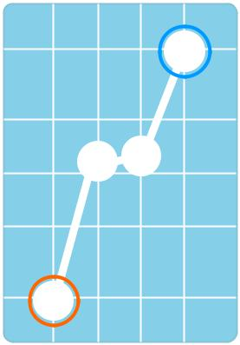

This is the classic rule-oriented sub-trait, of a person who needs to

be absolutely sure of their position and prefers to use established regulations and procedures as a framework to support their ideas. This aspect of their personal style extends to the need for practical

support from managers, colleagues and friends, and so they seek to _{D} maintain positive working relationships with others.

Accuracy

C/I : Compliance Higher than Influence

This sub-trait, (sometimes named Caution),hates to make mistakes

- they check and recheck their work, and are prone to correct errors in others, whether or not they have been asked to do so. This need for certainty means that they will never take a risk unless absolutely necessary. They are also cautious in communication, rarely revealing more about themselves than a bare minimum.

Sensitivity

C/S : Compliance Higher than Steadiness

People of this kind are extremely aware of their environment and changes taking place within it, to the extent that they often notice subtle points that other people miss or ignore. In itself, this is a positive factor, but it does have the consequence that they have a very low boredom threshold and are very easily distracted.

C
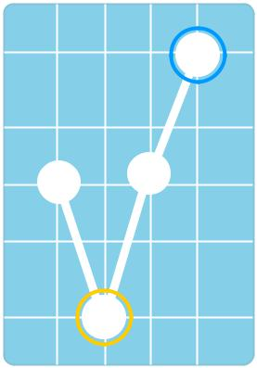

I
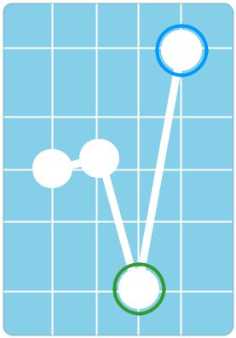

C

S

Changes Across a Series

Internal and External Profiles

It’s not unusual to see changes from one graph to another within a person's profile series. The important changes are those between the Internal and External Profiles, as we can see in the example below.

Example of a Profile Series
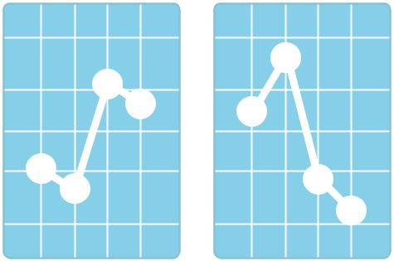

INTERNAL EXTERNAL
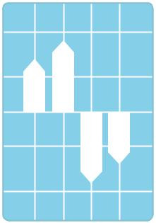

In this diagram, we have illustrated the changes, (shifts), between the Internal and External Profiles. In this case, Dominance and Influence are shifting upwards, while Steadiness and Compliance shift downwards.

Interpreting the Shift Pattern

The example suggests a person trying to present themselves as more assertive and communicative than is actually the case, while also attempting to demonstrate a more urgent, responsive style (the downward shift in Steadiness) and a greater willingness to take the initiative (the shift in Compliance). This type of pattern is not unusual in the modern workplace.

Example Shift:

Dominance Shifted Upwards

An upward shift in Dominance suggests that the person is attempting to present themselves as more direct and assertive than they would normally. They perceive their role as requiring a more independent and self-motivated style that they are naturally comfortable with. This shift in Dominance is often difficult to maintain, and may result in stress over the long term.

The important changes are those between the Internal and External Profiles

SHIFTS

This extreme example describes a person who seems to be trying to fulfil a role completely at odds with their natural style. This is because the Internal Profile (the natural style) is considerably different from the External Profile (which describes the kinds of reactions appropriate to their current circumstances, and particularly their work life).

Each shift has a different significance - some are relatively common, (such as the downward shift in Steadiness), while others can represent a more difficult adaptation. The size of the shift is also important. Small shifts of a few percent are very frequent, and unlikely to represent serious difficulties, while larger shifts (nominally, larger than twenty-five percent or a quarter of the graph) will have greater significance. Here are the eight possible shifts across a series.

More Shift Descriptions

Discover more about the way that different shifts in DISC factors affect a person’s behaviour in our full online reference guide.

DISC Profile Interpretations

Here we review some of the most significant features of a series of common DISC profiles, to show the range of DISC interpretations DISC can produce. There are numerous possible gradations within a DISC profile, and this reference section can only cover a handful of the most common in very brief terms. For a fuller assessment of a particular profile, a separate report is strongly recommended.

A Note on Notation

The notation used here has high factors and low factors separated by a forward slash, so for example D/I indicates high Dominance and low Influence (without any other high or low factors).

High Dominance (D/ISC)
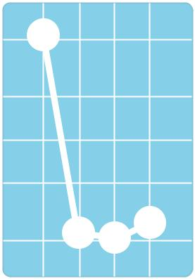
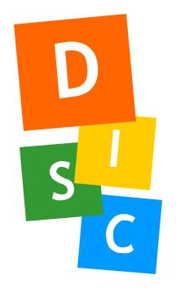

Decisive, Ambitious, Competitive, Driving

The High-D profile is often described as the Autocrat. Dominance is the factor of control and assertiveness, and with no other high factors in the profile to balance this, the pure High-D can be very domineering, and overbearing. This person has a very high need to achieve, and they are often ambitious and competitive, striving aggressively to achieve their goals. They are dynamic and adaptable, and show a decisiveness and a capacity for direct leadership.

High Influence (I/DSC)
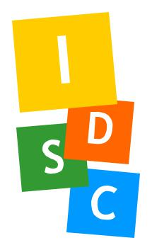
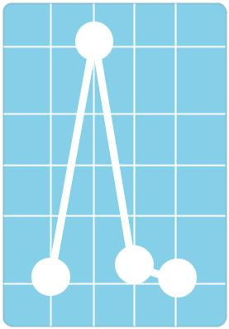

Confident, Outgoing, Expressive, Sociable

Influence is the factor of communication. A profile with this factor strongly represented, showing high Influence with no other balancing factors, represents a style that communicates easily and fluently with others. It is for this reason that profiles of this kind are often referred to as 'Communicator' profiles - they describe confident, outgoing and gregarious individuals who value contact with other people and the development of positive relations.

High Steadiness (S/DIC)
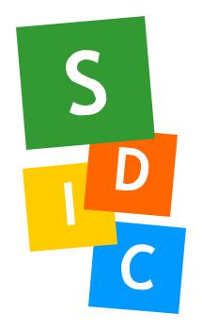
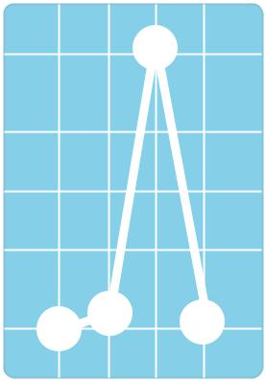

Measured, Accepting, Neighbourly, Stable

This type of profile, showing a high level of Steadiness with no other balancing factors, is comparatively rare. Steadiness is the factor of patience, calmness and gentle openness, and a pure High-S will reflect these qualities. They are generally amiable and warm-hearted, being sympathetic to others' points of view, and valuing positive interaction. They are not outgoing by nature,

DISC Profile Interpretations

High Compliance (C/DIS)
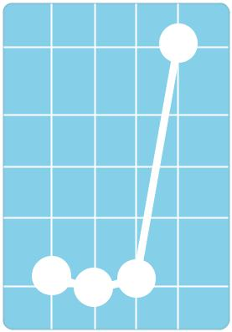

Diplomatic, Factual, Organised, Impartial

Unassertive by nature, often reticent and aloof, people of this kind can give an impression of coldness or disinterest. Often reluctant to reveal information about themselves or their ideas unless absolutely necessary, highly Compliant individuals tend to lack assertiveness and are generally unwilling to become involved in confrontational situations. Instead, they will tend to rely on structures and rules, and such people typically have a systematic and orderly approach to life.

Other Common DISC Profiles

High Dominance & Influence (DI/SC)

Pro-Active, Self-Confident, Assertive, Extrovert

High Dominance & Steadiness (DS/IC)

Determined, Resilient, Resolute, Committed

High Dominance & Compliance (DC/IS)

Self-Reliant, Objective, Demanding

High Influence & Steadiness (IS/DC)

Sympathetic, Supportive, Friendly, Confiding

High Influence & Compliance (IC/DS)

Accommodating, Diplomatic, Conforming

High Steadiness & Compliance (SC/DI)

Analytical, Patient, Restrained, Cautious

High Dominance, Influence & Steadiness (DIS/C)

Informal, Emotional, Candid, Talkative

High Dominance, Influence & Compliance (DIC/S)

Flexible, Dynamic, Exploratory, Questioning

High Dominance, Steadiness & Compliance (DSC/I)

Analytical, Precise, Dependable, Factual

High Influence, Steadiness & Compliance (ISC/D)

Co-Operative, Team-Orientated, Courteous

Compressed (-/-)

DISC in Practice

Putting DISC to Work

DISC profiles have a wide range of uses. Recruitment is the main area of application at present, but profiling techniques present possibilities far beyond this. Now we’ll looks at some of the application areas where the DISC system can be most effective.

Assessment

Regular assessment is becoming more widely used in the commercial sector, helping a manager to foresee and preempt problems with staff, and improve motivation and morale. This section covers the practical issues involved in maintaining a regular assessment schedule.

Addressing Specific Problems

From time to time, specific difficulties arise related to one individual, or an internal problem within a small group. We’ll show how DISC can be helpful in isolating the causes of these problems, and developing strategies to resolve them.

Important Note

No decision affecting a person's career should be taken solely on the basis of a behavioural assessment. Other factors such as skills, training or experience must be taken into account.

Recruitment

The main use of commercial profiling is as an aid to the selection of candidates during the recruitment process. We’ll examine DISC's use throughout the recruitment cycle, from the preparation of short-lists to the interview itself.

Cultural Integration

Cultural Integration is the process of integrating a successful new candidate into an organisation's (or new department's) existing culture. We’ll cover the role of profiling in easing a candidate's transition into a new work environment.

Redeployment

Redeployment within an organisation is a similar process to recruitment. We’ll look at the issues involved in redeploying to fill new roles within an organisation, or in transferring staff members to different positions.

Team Building

The behavioural styles of its members and the ways they interact has a large role in the effectiveness of any team. The use of DISC as part of the team-building process can have a significant positive impact.

Career Development

For those seeking a new career direction, or looking for their ideal job, DISC provides some useful guidelines. We’ll examine DISC's abilities in the area of career development.

Recruitment

Find the Right People with DISC

DISC can be used to perform a wide variety of functions, recruitment being the one that sees most activity. In fact, many people see DISC systems simply as a recruitment tool. This section looks at four popular and effective recruitment applications of DISC, and examines the advantages.

Make Recruitment Easier with DISC

Online profiling

It is often impractical to arrange individual testing sessions for a large number of candidates. Instead, a cloud-based approach allows you to schedule profiling across the Internet, allowing candidates to complete their profiles at their convenience, and making reports instantly available to you as soon as each profile is completed.

...candidate matching can quickly identify candidates whose personality is well suited to the job

Candidate Database

Maintaining a DISC-based candidate database makes it easy to find suitable profile types. It’s also possible to organise candidate profiles to work with separate recruitment campaigns.

Candidate Matching

If you have a job profile defined for a role, the process of candidate matching can quickly identify candidates whose personality is well suited to needs of that role.

Shortlisting

In times of economic hardship, job vacancies attract large numbers of potential candidates. Applications often run into the hundreds, or even thousands, far more than can be practically interviewed. Most organisations solve this problem by drawing up a shortlist, interviewing only the members of this list.

With so many applications, however, producing this shortlist is a time-consuming and difficult task. Standard application forms and curricula vitæ rarely convey enough to make a solid decision about a candidate's suitability. This is where DISC can help.

- DISC questionnaire can be included with application forms. This will allow a picture of applicants’ styles to be built up relatively quickly. Results can be compared against a predefined ideal profile for the job, expediting the shortlisting process.

It is important to note that in shortlisting, DISC is merely a useful aid. To draw up a complete shortlist from styles alone is not practically possible, because DISC has no way of addressing other important issues, such as qualifications and experience.

Recruitment

The Interview

The ultimate use of DISC results is to aid the interviewer during the interview itself. It can do this in many ways.

The DISC interpretation of a candidate's profile can highlight potential difficulties that would never emerge in the course of a normal interview. These problem areas can be probed by the interviewer to assess their relevance. Almost all DISC systems can generate a list of disadvantages of this kind, but some of the more advanced, automated, systems are able to go one step further and generate a list of problem areas relative to a specific job, and even provide a list of suggested behavioural questions for the interview.

DISC can also help to improve communication within the interview. This is a more subtle and less tangible benefit, but it can have a significant impact on the progress of the discussion. By making themselves aware of an interviewee's motivating factors, the skilful interviewer can encourage them to reveal information, and help to relieve the understandable pressure of an interview situation and so ease communication. Some interviewers actually discuss a candidate's DISC report with them during the interview.

Handling Rejection

A little-used approach, but one that is growing in popularity, is the application of DISC to ease rejection

of unsuitable candidates. Some organisations now include a DISC report with rejection letters, giving the candidate a clear idea of the reasons for their rejection, and offering them guidance in the further development of their career. This positive approach can not only help relieve the disappointment of unsuitable candidates, but also improve the perception of the organisation.

Cultural Integration

About Organisational Cultures

Any successful recruitment process is followed by a phase of cultural

integration. This describes the process by which a new member of staff adapts to a new organisation, and the particular culture of that organisation. This important step is often overlooked by recruiters, but is gradually growing in importance among human resource professionals.

What is an organisation's culture? Essentially, any close-knit group of people will, over time, develop a set of

Integrating a New Recruit

traditions, customs and unwritten rules that define the ways in which they work together. One of the most stressful times for a newly recruited member involves coming to terms with this set of cultural factors, and adapting to work within them.

Cultural integration is growing in importance with HR professionals.

Many of the elements of a culture of this kind are highly specific, and unsuited to assessment through a behaviour-based system. On a more general level, however, there are often aspects of a culture that suggest an analogy between an individual's approach and the general style of the organisation as a whole. A very formal, rigidly structured working environment could be characterised as a High-C organisation, for example, while a workplace that placed emphasis on personal initiative and internal competition would be more appropriately described as a High-D organisation.

By comparing a new recruit's behavioural style with that of the organisation, we can highlight those areas where they will have difficulty in adapting to their new environment, as well as discovering those areas in which they are particularly well suited. Using this information, it becomes possible to guide an individual's induction into a new organisation, rather than simply leaving them to fit in as well as they can. Achieving this

in an effective manner clearly takes a great deal of skill, experience and patience, and this is perhaps the reason why this application of DISC is comparatively rare in comparison with its other uses. Nonetheless, many individuals who might be otherwise suited to a job leave in the first few months, and this points to the need for greater attention to the cultural integration phase.

Assessment

Managing a DISC Assessment Programme

A regular assessment schedule is part of the human resources policy of a growing number of companies.

By appraising performance through interviews and management reporting, it becomes possible to build a comprehensive picture of staff performance, and isolate any problems before they grow to serious proportions. The inclusion of DISC profiling in this process can further enhance its effectiveness. There are a variety of ways that DISC can help to isolate problems and suggest possible solutions. These include:

Divergent External Profiles

If a particular individual shows marked shifts between their Internal and External profiles, this is an indication that they feel somehow uncomfortable in their current position. This might indicate that they are unsuitable for their present work, or it simply reflects an inaccurate perception of the requirements of their position. Discovering which of these possibilities applies can usually be achieved by comparing the profile series with a Job Profile for the staff member's role.

Compressed Profiles

The appearance of a Compressed Profile in a DISC profile series is often a pointer to some kind of long term pressure situation. In a work environment, a Compressed Profile is often a pointer to a lack of direction or certainty, suggesting that the person concerned feels unsure of the expectations of their colleagues and managers, or the nature of work that is expected of them.

Profile Tension

The stress levels, or profile tension, in a DISC profile series is a useful indicator of a person's state of mind. It is possible to assess whether any such tension stems specifically from the work environment, or associated with the individual's general lifestyle. In either case, high levels of stress will have a deleterious effect on performance over the long term.

Similarity of External Profiles

Where a large number of people working in a department show very similar External Profiles to one another, it suggests a subtle problem. Managers with very strong styles (dominant and highly assertive ones) can have a significant impact on their staff, to the extent where an entire

department's External Profiles adapt to meet the manager's expectations. While this phenomenon might actually be desirable in a highly structured environment, it is often associated with problems of motivation. This is because members of staff are being forced to suppress their natural abilities, impacting on their performance. Large shifts between the Internal and External profiles can also decrease motivation, again with a negative effect on performance.

DISC is one of the most

popular personality profiling techniques available today

Assessment Intervals

Assessment programmes using DISC should not be performed at close intervals. This is not normally a problem, because such assessments would normally be performed at six-monthly or annual intervals. As a minimum, a DISC questionnaire should not be applied on a person at closer intervals than three months.

Redeployment

Reallocating Roles

Redeployment refers to the reallocation of roles within a department or organisation. In many ways, it is similar to the recruitment process, but with a greater volume of first-hand information available about potential candidates. If the organisation is a regular user of DISC-based assessment, then this information will include DISC profiles. This can be of great help in identifying the right candidate for the right role.

There are two main types of redeployment, which we call organisational and individual. There are significant differences of approach applicable to each of these.

Organisational

Redeployment

This term describes situations in which new positions or roles are opening up within an organisation, that should ideally be filled by existing members.

DISC is the ideal tool for quickly and easily comparing individuals’ behavioural profiles against the job profile to help select the best candidate for the role or position.

An computerised DISC system, (such as Discus), will make it practical to assess all members of an organisation against the requirements of the new position.

Individual Redeployment

Individual Redeployment is far less common than its counterpart. This term describes the situation where a person or group has to be relocated within an organisation. This will normally be due to their current roles becoming redundant, but other reasons may also occasionally arise.

DISC is ideal for easily comparing individuals’ profiles against the job

In DISC terms, this process is the reverse of Organisational Redeployment. Instead of matching a number of candidate profiles against an individual Job Profile, a number of Job Profiles representing the available posts will be matched against only a few candidate profiles.

This means that the use of assessment in this field is more difficult to achieve than Organisational Redeployment, because most DISC users maintain files of recruited candidates' DISC profiles, but very few possess a complete set of Job Profiles covering every role within their organisation. Such a database of Job Profiles can bring real advantages, but practical limitations to its construction will usually mean that it is only achievable by an automated DISC system.

Team Building

Building Successful Teams with DISC

Why is it that some teams work smoothly and effectively together, while

others break down into internal conflict and achieve little? One of the main factors is the interaction of different styles within the team. DISC provides a useful predictor of team effectiveness by highlighting possible problem areas and suggesting ways of resolving them.

The ideal composition of any team is dependent on the team’s task,however, the key to success is diversity. Each main DISC factor draws an individual to play a different part in the team structure, and a variety of factors across team members can help to ensure that the team performs effectively.

DISC Factors and their Team Roles

The ways that different DISC profiles break down into roles within a team are complex. A full analysis can break down personality types into no less than twenty-seven distinct team roles.

We can gain an idea of the parts they play in the development and performance of the team by looking at the four DISC factors. Remember, this is simplified; in reality, the factors work in combination to produce a whole range of team attitudes.

Dominance, being the factor of control, is most suited to a leadership role. Dominant people have a natural urge to take command, and will fit easily into such a position. However, the number of High-D team members should be kept to a minimum. Several people attempting to take leadership will clearly have a negative impact on team performance..

Influence is the social cement of the team. Unless they possess specialised skills, highly Influential people often appear to have little practical part to play in the team's proceedings, and are hence often undervalued. For a team to work effectively, its members must have a sense of cohesion, and this can be achieved by the inclusion of one or two Influential individuals. The communicative abilities of Influence can also produce a representative or spokesperson, presenting their findings and ideas to others.

Team Building

Steadiness is the team's brake, holding the other members back from ill-considered conclusions or precipitous actions. This is an important factor, especially after the team has formed its internal social relationships and has begun to perform its real function. Steady individuals lack assertiveness, which can often prevent them from making input unless directly requested, and it is often helpful to develop the structure of the team in such a way that the Steady members feel that their contributions will be valued and accepted by other team members.

Compliance is an important factor in achieving the team’s results. Members with high Compliance tend to generate ideas and produce materials and reports. The less pro-active side of the Compliant type, however, will normally require more assertive team-members ( Dominant and Influential types) to implement and monitor any plans or suggestions they produce. The Compliant members of the team often possess the specialised skills and knowledge appropriate to a project.

For any team to be effective over the long term, it must pass through an initial period of flux and uncertainty before it performs, during which relationships and roles are formed. This formative period is an ideal time to introduce any formal structures considered necessary to the smooth running of the group.

More Elements of Team Building

The following looks at teams in simple DISC terms to give you an idea of the ways each factor will affect a team as a whole. Naturally there’s a great deal more at work in the operation of a team, and DISC can give us more insights in a whole range of areas.

Team Dynamics

Dynamics refer to the relations of different DISC factors from one individual to another. In the context of a team, they can help to highlight the most important relationship questions at work between group members.

Team Leadership

Personality has a great deal of influence on leadership. Not only will the leader’s own approach affect the team as a whole, but the personality styles of the team’s members will describe their different needs and expectations from a team leader.

Team Roles

Breaking down team members according to roles is a well established approach, and DISC can offer a structured way to do this. A DISC team assessment can describe team members as belonging to any of twenty-seven defined role types, based on their personal profiles.

Career Development

Planning Career

Paths with DISC

In the earlier parts of this section, we have seen a number of ways in which DISC can be used to help in purely business-oriented matters, mostly relating to either the recruitment or assessment of staff.

Outside this corporate arena, however, DISC can also contribute to personal development. The clearest example of this is in helping with an individual's career development and their career path.

A person's DISC profile series is compared against an ideal job profile

Important Note

It is important to note that there are multitude of factors that must affect the decisions a person takes about their careers. DISC alone cannot provide a definitive conclusion, but it is able to provide guidance in deciding whether a particular career path is suited to an individual or not. Also, DISC results tend to be less reliable for young people under the age of twenty, because before this age the behavioural trends tend to be in a state of flux. The precise age at which a behavioural style reaches a stable form will naturally vary from individual to individual.

DISC Career Matching

Using DISC for career development is a similar process to that seen in recruitment or assessment scenarios. A person's DISC profile series is compared against an ideal job profile for a particular career, and the closeness of the match between the two styles will give an indication of how well that individual's style is suited to the career being investigated.

While this is an appropriate method, it becomes inappropriate if a person has no clear idea of the type of career they might be interested in. This situation might apply, for example, to students leaving college or university. In this case, a library of job profiles is needed, representing a wide variety of different job styles in different career areas. Comparisons of this

kind, incorporating hundreds of possible matches, are impractical for manual DISC systems, but this kind of matching is sometimes provided by automated DISC applications. This can be a very effective means of raising new career ideas that a person might not have considered.

Once a career decision has been made, DISC can also help in preparing application letters and curricula vitæ (or résumés). DISC profiles help to highlight the particular areas of strength within a person's style, and these can be included in applications. Because so many organisations use DISC, it may even be useful to include a full printed DISC report with a job application.

